## Calculus in Higher Dimensions

Background

This topic deals with extending concepts such as limits, continuity, differentiation, and integration, studied in first year calculus, to functions of several variables. Topics covered:

- Continuity of functions of several variables.

- Limits, partial derivatives, gradients, directional derivatives, divergence, and curl and apply these concepts to problem solving.

- Nature of extrema and optimization problems using Lagrange multipliers.

- Determine double and triple integrals and use them to calculate areas and volumes.

- Determine line, surface and flux integrals and apply the theorems of Green, Stokes and Gauss, which relate these types of integrals.

The Study Guide Splits the above topics into three distinct units:  
Basic Concepts

* Preliminaries (Sets, Relations, Implications, Symbols)
* N-dimensional Euclidian space (R, dot products, Norm, Distance, Unit Vectors, Basis Vectors, Angle between vectors, Cross Product, Lines, Subsets)
* Functions (visualisation, Rn-Rp)

Differentiation

* Limits and Continuity (R-R functions, Rn-R functions, Real Valued functions, Limits along curves, Vector Valued functions, Continuity)
* Derivatives Real Valued functions (One Variable)
* Derivatives Vector Valued functions (Chain Rule, Piecewise smooth curves)
* Derivatives Real Valued functions (Several Variables) (Rn-R functions, Gradient of Rn-R functions, Differentiability of Rn-R functions, Chain Rule, Directional Derivatives Rn-R functions, Potential Functions, Higher order Partial Derivatives)
* Derivatives of Vector Field
* Taylor Polynomials (R-R functions, Rn-R functions)

Integration

* Single Integrals
* Double Integrals
* Triple Integrals
* Line Integrals
* Surface Integrals
* Flux Integrals
* Theorems (Green, Gauss, Stokes)

**Lesson 1**

dimensional Euclidean Space

: One-dimensional space

Can be represented as a straight line

Corresponds with the set of real numbers

Written as the ordered tuple

: Two-dimensional space

Can be represented geometrically as a plane

Corresponds with two mutually perpendicular copies of , called the axis and axis

Origin denoted , is the point

Written as the ordered pair

: Three-dimensional space

Can be represented geometrically as a plane

Corresponds with three mutually perpendicular copies of , called the axis, axis and axis

Origin denoted , is the point

Written as the ordered tuple

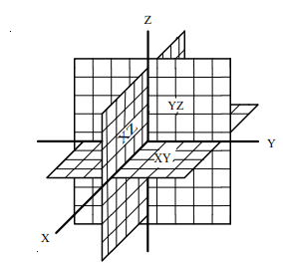 *right hand rule coordinate planes in*

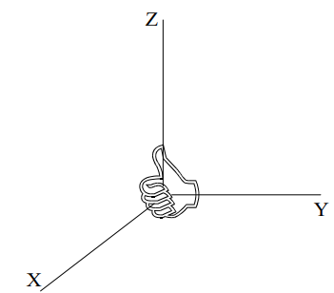

**Lesson 2**

Vectors in

The standard geometric definition of vector is as something which has direction and magnitude but not position. Since vectors have no position, we may place them wherever is convenient.

A vector in is a tuple

*Essentially a matrix*

written as: and

**Vector Addition**

**Vector Subtraction**

**Scalar Multiplication**

Two vectors and are parallel if they are scalar

multiples of one another

where

*Algebraic definition of parallel vectors in*

Example: Which of the following vectors parallel?

*This number should not have a remainder*

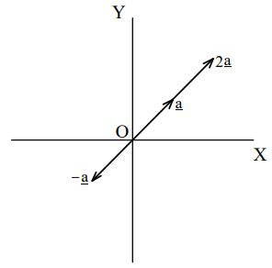

**Cross Product**

Two vectors and are perpendicular

their scalar product is equal to zero

Example: a vector perpendicular to the

vectors and

*Standard basis vectors in are denoted by , and*

**Dot Product**

The Norm in (length in )

*Dot product is a real number (scalar product)*

Example: the length of the vector

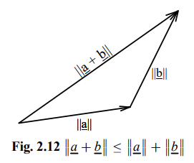

**Lesson 3**

Planes in

A non-zero vector is parallel to a plane in if it is parallel to some line in the plane.

A non-zero vector is perpendicular to a plane if it is perpendicular to every line in the plane

A plane is uniquely determined by a point on the plane and a vector perpendicular to the plane. Any vector perpendicular to a given plane is called a normal of the plane

**Dot Product**

is a point on ,

is a vector perpendicular to

is any other point on

Thus, the plane consists of all points

in that satisfy the equation

Or

**Lesson 4**

Parametric Equations

A parametric equation is where the x and y coordinates are both written in terms of another letter. This is called a parameter and is usually given the letter t or . ( is normally used when the parameter is an angle, and is measured from the positive x-axis.)

Example: Plot the graph of

*Chose some random values for t*

|  |  |  |  |  |  |  |  |  |
| --- | --- | --- | --- | --- | --- | --- | --- | --- |
|  |  |  |  |  |  |  |  |  |
|  |  |  |  |  |  |  |  |  |
|  |  |  |  |  |  |  |  |  |

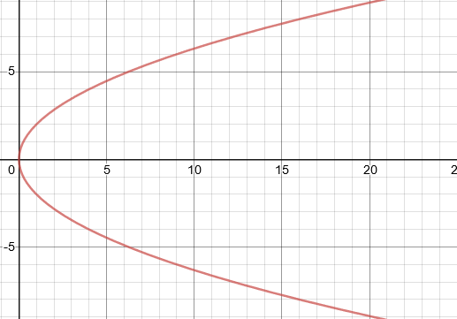

Desmos Graphing Calculator

*Don’t simplify further,*

Example: Plot the graph of

*Chose values for t which will give a good range of points for*

|  |  |  |  |  |  |  |  |  |  |
| --- | --- | --- | --- | --- | --- | --- | --- | --- | --- |
|  |  |  |  |  |  |  |  |  |  |
|  |  |  |  |  |  |  |  |  |  |
|  |  |  |  |  |  |  |  |  |  |

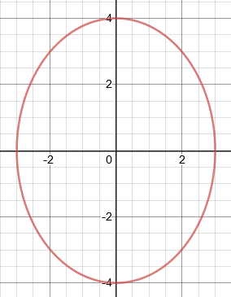*Try write the equation in the form ,*

Desmos Graphing Calculator

ASS1 Q1–:

Find the point of intersection , If there is one, of the following lines:

If and intersect, there is a point that lies on both lines. There must be such that:

*and are only distinguished for legibility*

If and intersect, there is a point that lies on both lines. There must be such that:

If and intersect, there is a point that lies on both lines. There must be such that:

Therefore, , which is a point on and

If and are in the plane they describe, the normal to the plane must be perpendicular to and

*Cross product*

*Find the determinant of , and*

*The sign of must be a minus*

*To evaluate a 2x2 matrix, use*

, which is a point on the plane

*Dot product*

ASS1 Q2: Find the equations for the line of intersection of two planes

*Choose the arbitrary point where*

*Use matrix to solve system of equations*

*Multiply both sides of the matrix equations with the inverse*

Therefore, a point that passes through the plane is

Therefore,a vector that describes the direction which it travels is

Therefore, the equation for the line of intersection of two planes

ASS1 Q2: Find the equations for the line of intersection of two planes

**Alternate Solution**

*Convert into matrices*

**Lesson 6**

Quadric Surfaces

<https://tutorial.math.lamar.edu/classes/calciii/quadricsurfaces.aspx>

These are the three-dimensional representation of a surface in 3 dimensions. These are in the explicit form where is a quadratic form in

Quadric surfaces are the graphs of any equation that can be put into the general form

|  |  |  |  |
| --- | --- | --- | --- |
| Shape | Form | Shifted form |  |
| A picture containing object, umbrella  Description automatically generated  Ellipsoid |  |  | If then we have a sphere |
| A close up of a wire fence  Description automatically generated  Cone |  |  |  |
| A picture containing building  Description automatically generated  Cylinder |  |  | This is a cylinder whose cross section is an ellipse  If then we have a cylinder whose cross section is a circle |
| A picture containing game, basketball  Description automatically generated  Hyperboloid (of one sheet) |  |  | The variable with the negative in front of it will give the axis along which the graph is centred |
| A picture containing game, table  Description automatically generatedHyperboloid (of two sheets) |  |  | The variable with the positive in front of it will give the axis along which the graph is centred. |
| A close up of a basket  Description automatically generatedElliptic  Parabaloid |  |  | As with cylinders this has a cross section of an ellipse and if it will have a cross section of a circle |
| A picture containing dress, umbrella  Description automatically generated  Hyperbollic Hyperboloid  A picture containing drawing  Description automatically generated  A picture containing building, tower  Description automatically generated |  |  |  |

ASS1 Q3:

a) Consider the surfaces in defined by the equations

is a Cone (top portion)

is an Elliptic/Circular Paraboloid

is a Hyperbolic Hyperboloid) Intersection where

Desmos Graphing Calculator

*The intersection of and is a circle*

**Lesson 7**

Partial Differentiation

Differentiation you have dealt with until now has been with functions over a single variable

But realistically, you will come across functions with two or more independent variables, which may represent space/time.

Like quadric surfaces, these can be explicitly represented in the form

. If , then:

or or or or

or or or or

Example: Given , find and

1) Find

2) Find (partial derivative with respect to )

­*treat y and z like constants*

2) Find (partial derivative with respect to )

­*treat x and z like constants*

3) Find (partial derivative with respect to )

­*treat x and y like constants*

4) Find

4) Find

**Lesson 8**

Limits for multi-variable functions

Limits help solve the problem of indeterminate form

Calculating instantaneous velocity is an example of a limit

Say we have two different limits:

Then all the following are true:

Example:

Since this function has concepts we are familiar with (quotient, addition, product), we can just plug in values for and

Example:

try factoring this time

**Lesson 9**

Limits for multi-variable functions: Precise definition

<https://www.youtube.com/watch?v=CCDxj3g_BVk>

Factoring and plugging in a value for and is easy, but what about the definition?

**Epsilon-Delta definition**

Single variable

If

Then

*The distance needs to be positive, hence ABS*

*As x approaches some random point a, the limit is L*

With the above graph we are looking to define intervals around .

We do this so that we can ignore everything outside of the interval

This helps us use the precise definition

on the y axis corresponds with

on the y axis corresponds with

If we chose a good value for (a delta distance from ), automatically we have a corresponding good value for (an epsilon distance from )

**Epsilon-Delta definition**

Multi variable

If

Then

*Because . This will always be a positive number*

*As the coordinate system approaches some random coordinate point the limit is L*

With the above graph we are looking to transfer everything we now know about a single variable onto a 3-dimensional system.

So instead of two lines, we now have a circle as our interval

is now the radius of this circle

A value of will correspond to some value of

How to use the precise definition

[1] Continuous: Plug in values or factorise

Path 1

*Path along x-axis, as we approach origin*

[2] Not Continuous: Show that limit (try different paths)

*In single variable, this was just showing that*

*In multi variable, test several different paths. Two of these need to be different*

Path 4

*Parabola path that passes through origin*

Path 3

*Non-vertical line that passes through origin.*

Path 2

*Path along y-axis, as we approach origin*

Path 5

*Parabola path that passes through origin*

[3] Use precise definition

*If you get the same answer for all random paths, use the precise definition*

*At this point, we think is (all our paths led to ). Also and*

If

Then

*Neaten the above*

If

Then

whenever

*We start by removing ABS. The denominator doesn’t need ABS as sqrt b positive*

*The same applies for , it will be positive. We don’t need the zero inequality*

whenever

*Our goal is now to find a relationship between delta and epsilon.*

Let’s create some inequalities

*If you try for instance, RHS will be greater*

*Since the numerator is greater than the denominator.*

*1 is used because*

*Since the LHS < 1 (e.g. ), it will probably reduce y*

*e.g. -3 (LHS) will be less than 3 (RHS)*

Therefore,

SEM 1 ASS 1: Q4

Given ,

**Epsilon-Delta definition**

Multi variable

If

Then

*Because . This will always be a positive number*

*As the coordinate system approaches some random coordinate point the limit is L*

Prove from first principles that

If

Then

*Substitute =-1, ,*

If

Then

*Substitute , .*

*Add and for extra constants created by substitution*

If

Then

If

Then

From the Epsilon-Delta definition above, we now must find some relationship between and

or

Now we can start with the calculation using the function

*triangle inequality*

*Substitute ,*

From our earlier definition

If

Then

But for any if , then

Therefore

*Substitute*

If

Then

*Multiply all expressions by 6*

If

Then

If

Then

We can see that for any . Therefore